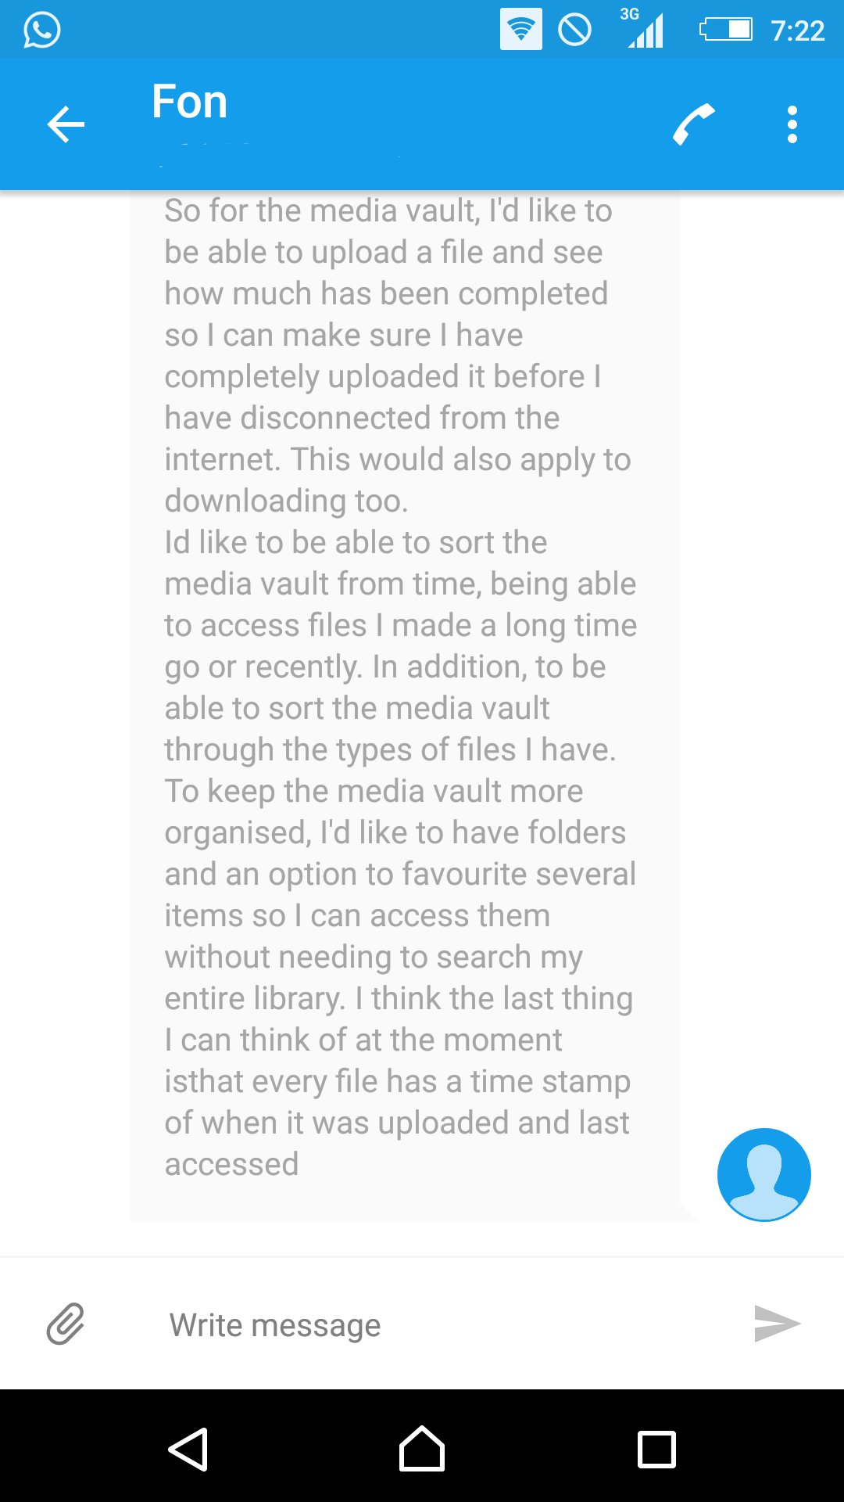

-----

Course filtering, warning system

As a university student, I want to have access to the textbooks related to my course so that I can view only the textbooks I need.

A filtering system will be implemented that lists the available courses in QUT and the associated textbooks. The university student will be able to access their selected course and the textbooks related to which unit code. The system will enlist the prescribed and recommended textbooks for the selected course and units for the related university student. The database will be complete with the courses and units of the university, allowing for accurate detail.

As a buyer, I want to know that this seller can be trusted so I can have a successful transaction.

To ensure the community is safe for transactions, users will get three strikes before a permanent ban is placed upon the user, halting all further transactions. This eliminates the users which are causing unpleasant transactions or are not fulfilling their side of the transaction. Warnings will be sent to users once they receive a strike, while future transactions will present a strike on the user to allow the community to be aware of their seller. Users will be enlisted through their QUT email which reduces the likeness of the user reappearing on the website.